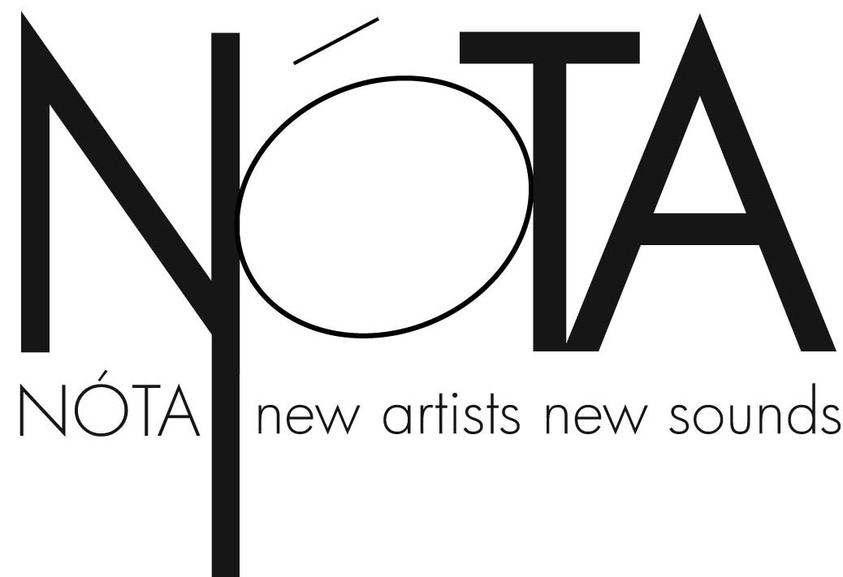
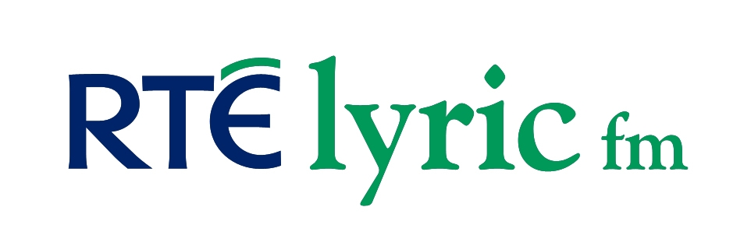

** PRESS RELEASE ** For Immediate Use **

Thomas Hampson – A Panorama of American Song
National Concert Hall, Dublin
Sunday 30th May 2010 at 8pm

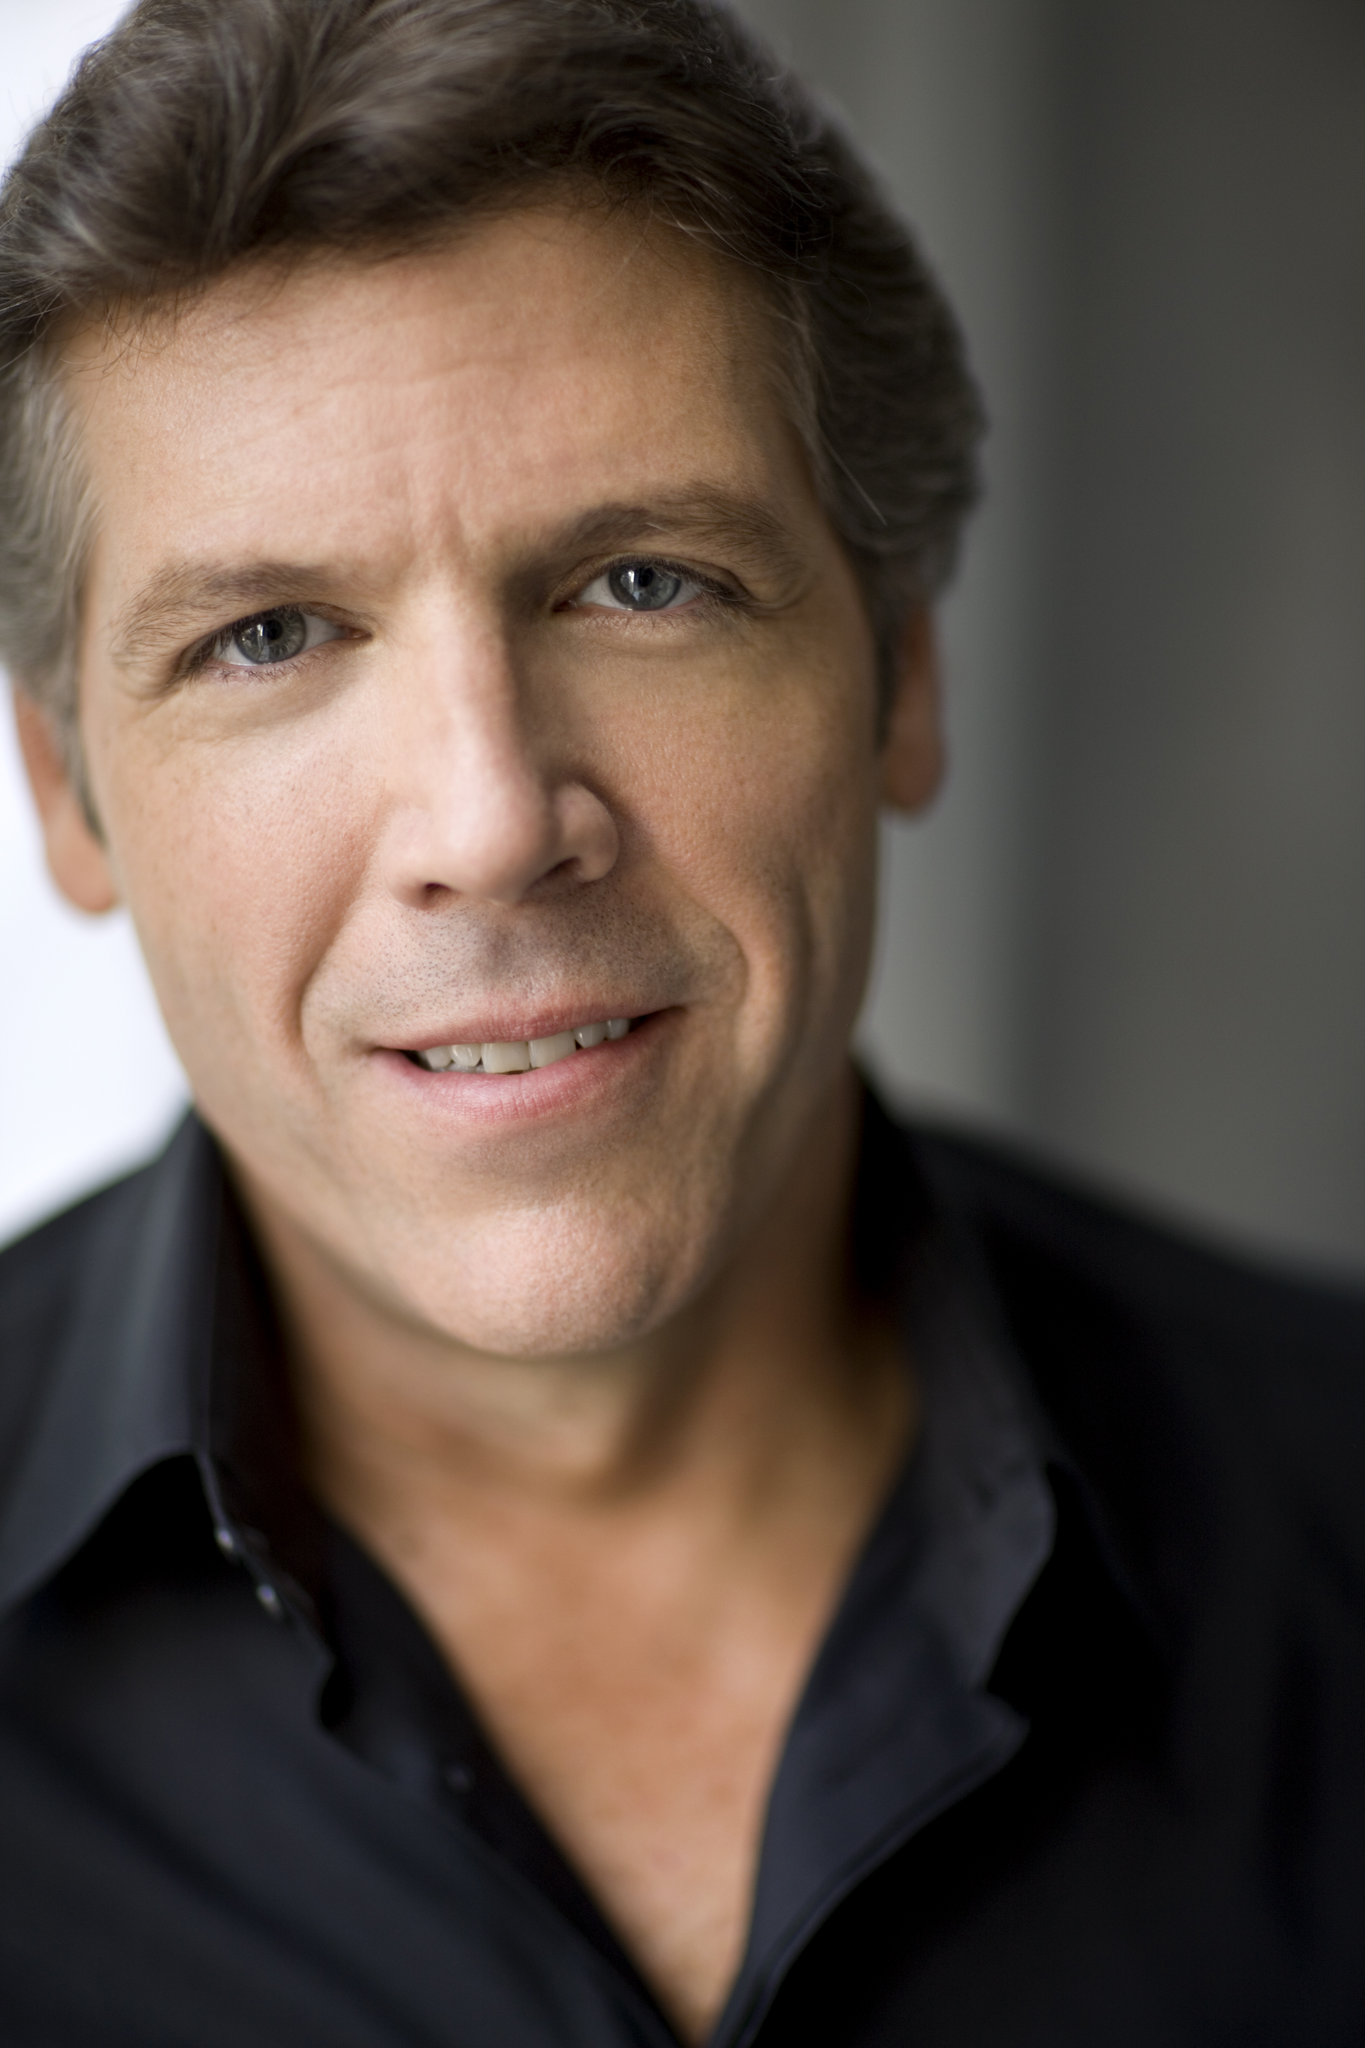Nóta, in association with RTÉ lyric fm, is delighted to welcome world-famous American baritone Thomas Hampson to Ireland for a rare recital in the National Concert Hall, Dublin on Sunday May 30th 2010 at 8pm. Thomas Hampson is widely recognised as one of the world’s finest baritones and most compelling performers. He comes to Dublin at the peak of his powers with a repertoire of American Song for which he has acquired world-wide renown.

“If American song needs an evangelist, no one is better equipped to do the job right than Thomas Hampson….with a voice like oiled oak, capable of infinite tonal shadings, and a gift for storytelling possessed by few of his colleagues, Hampson made each song as dramatically potent as any character in his operatic arsenal.”
Photograph by Dario Acosta
Chicago Tribune

Over the last ten years, American Baritone Thomas Hampson has become renowned worldwide as the champion of the 250-year-old tradition of American Song [see note 1 and 2 below] - both through his Hampsong Foundation which is dedicated to the support and proliferation of art song, and as an interpreter of the music on record and the concert stage. Always a favourite with Irish audiences, especially for his classic performances of Stephen Foster songs (“Hard Times Come Again No More”, “I dream of Jeanie with the Light Brown Hair”), Thomas Hampson has chosen repertoire from among others his two acclaimed CDs Song of America (2005) and Wondrous Free: Song of America II (2009) for his Dublin recital. He will be joined by his regular collaborative partner, German pianist Wolfram Rieger.

Tickets priced €45, €55, €60 and €70 (€30 Choir Balcony) are available from www.nch.ie.

For more information, please contact,
Josh Johnston
Nóta
Mobile Tel: (086) 892 0602
Josh.johnston@nota.ie
www.nota.ie

c/o 20 Burdett Avenue
Sandycove, County Dublin
IRELAND

Notes to Editors:

1. On the background of American song: In 1758, Francis Hopkinson composed the first American art song, My Days Have Been So Wondrous Free. Although largely rooted in European Classical music, the song sowed the seeds for one of the most varied musical forms. The collection of songs that followed over the next two centuries (by composers such as Charles Ives, Stephen Foster, Leonard Bernstein, Edward McDowell, Samuel Barber, Paul Bowles and others) is wide-ranging in influence and mood. It is a very American art-form drawing now on popular and folk music forms as much as classical music. The music is in turns poignant and humorous, wistful and urgent, intimate and melancholic - original music and settings of folk and sacred music documenting the American experience over the last 250 years in a most sophisticated, yet accessible way
2. The Hampsong foundation supports research and young artists through symposia, masterclasses, and concert lectures. See www.hampsong.com
3. Nóta is a Dublin-based independent music promotion company established in 2007 by musician, singer, linguist and business consultant Conor Daly to promote new and classical music and artists. www.nota.ie

